**Europe leads in global imports of cocoa beans**

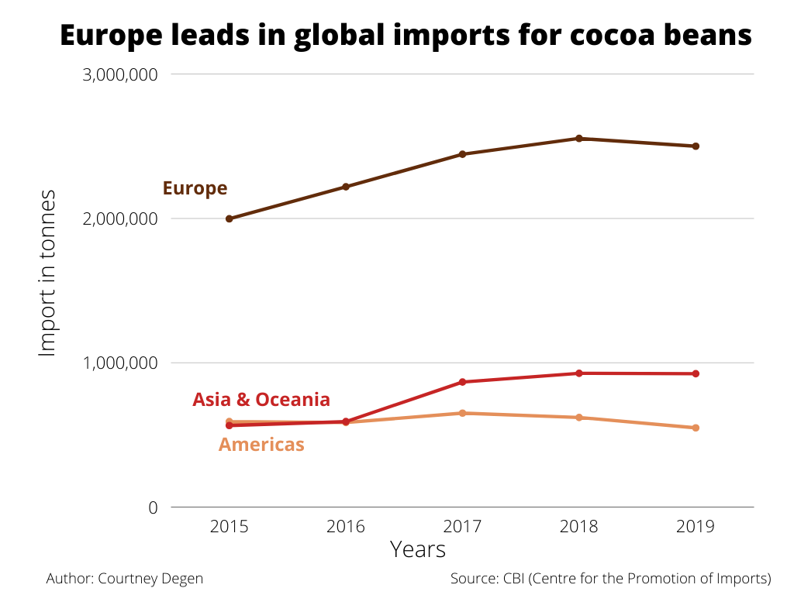In the years 2015-2019, Europe imported significantly more cocoa beans than other regions. At its peak in 2018, Europe imported over 2.5 million tonnes of cocoa beans, compared to 621,000 tonnes imported to the Americas that year.